
Helwan National University Faculty of Engineering

Automated Brain Tumor Segmentation via U-Net Architecture
Technical Report

Supervised by: Dr. Samar M. Nour

Prepared by: 1) Saif Hany Abdel-Aziz (ID : 921220062)
- Ali Ahmed Zaki (ID : 921220087)
- Marwan Hassan Morsy (ID : 921220142)
- Mohamed Emad Eldin (ID : 921220128)
- Tasnim Ahmed Mohamed (ID : 921220037)

Submission Date: 11/5/2026

- Executive Summary:
This project presents an end-to-end Deep Learning pipeline designed to automate the segmentation of brain tumors from MRI scans. By leveraging the U-Net architecture, the system achieves a high Dice Coefficient of 0.86, providing a reliable tool for clinical decision-making. The report covers the theoretical background, historical context of the architecture, and practical implementation details.

Problem Statement & Motivation:

The Challenge of Manual Segmentation
Manual delineation of tumor boundaries by radiologists is:
Time-Consuming: Each MRI volume contains dozens of slices.
Subjective: Significant inter-observer variability exists between different specialists.
Cognitive Load: High-pressure environments increase the risk of missing small lesions.

The Technical Hurdles
Medical images present unique challenges:
Low Contrast: Tumors often have similar intensity levels to healthy tissue.
Class Imbalance: The tumor pixels are statistically "rare" compared to the background.

Historical Context & Evolution of U-Net:

Pre-2015: The Sliding Window Era
Before U-Net, Convolutional Neural Networks (CNNs) used a "sliding window" approach, where the network predicted the label of a pixel by looking at its surrounding patch.
Disadvantages: It was extremely slow and lacked "Global Context" (it couldn't see the whole organ at once).

The Breakthrough (Ronneberger et al., 2015)
In 2015, Olaf Ronneberger and his team at the University of Freiburg introduced the U-Net at the MICCAI conference. It was a revolutionary modification of the Fully Convolutional Network (FCN).
The Innovation: The primary goal was to work with very few training images (a common problem in medicine) while providing high-resolution output.
Success: It outperformed previous methods in the ISBI cell tracking challenge by a significant margin.

Structural Analysis of U-Net Architecture:

The Symmetrical Backbone
U-Net is composed of two main parts forming the "U" shape:
    - The Contracting Path (Encoder): Acts as a typical CNN to extract high-level features.
    - The Expansive Path (Decoder): Responsible for "Up-sampling" those features back to the original image size.

The Role of Skip Connections (The Key to Precision)
The most critical feature of U-Net is the Skip Connections.
They pass high-resolution features from the encoder directly to the decoder.
Why? Because as we down-sample (compress) the image, we lose "where" things are (spatial information). Skip connections "remind" the decoder of the exact locations of boundaries.
U-net Model

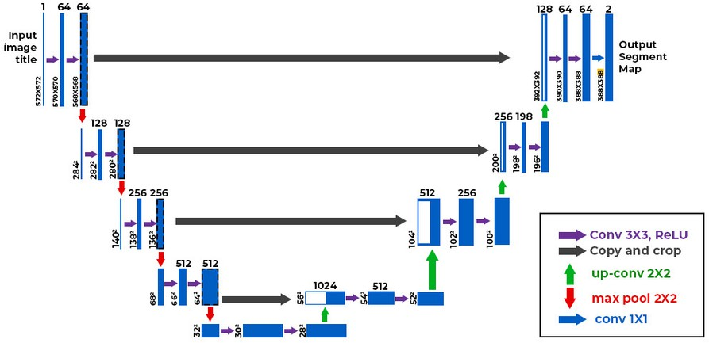

Proposed System Implementation:

Data Acquisition & Engineering
Input Resolution: Resizing images to (256 * 256) to balance computational cost and detail.
Augmentation Strategy: Using ImageDataGenerator for rotations, shifts, and
zooms to simulate different MRI machine angles.

Mathematical Objective: The Hybrid Loss
To overcome class imbalance, we don't just use Accuracy. We use a combination:
Total Loss = BCE Loss + Dice Loss BCE: Handles pixel-level classification.
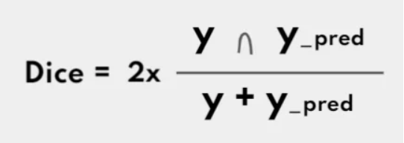
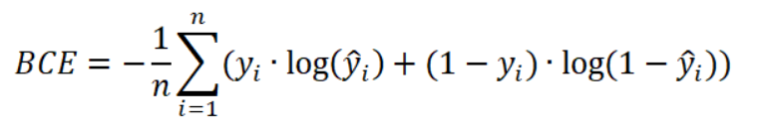
Dice: Focuses on the overlap between the predicted mask and the actual tumor.

5.3 Evaluation Metric: Intersection over Union (IoU)
Besides the Dice Coefficient, the model was evaluated using the Intersection over Union (IoU), also known as the Jaccard Index.
Definition: It measures the area of overlap between the predicted segmentation and the ground truth, divided by the area of union between them.

Mathematical Formula:
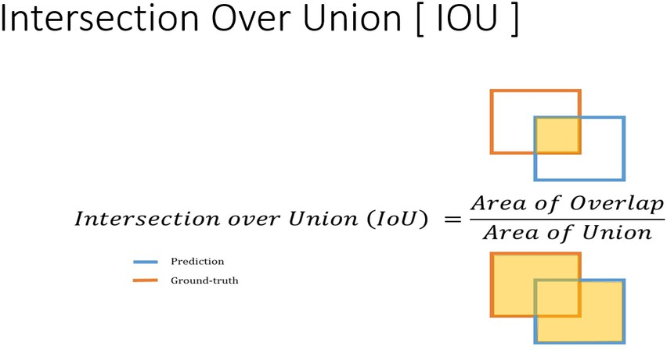

Why IoU? While the Dice score tends to be more "forgiving," the IoU is a stricter metric. Achieving a 0.75 IoU means that the model has a very strong spatial agreement with the actual tumor boundaries, which is a critical requirement for neurosurgical planning.

Training Optimization via Keras Callbacks:
To ensure the model reaches its optimal state without manual intervention, a suite of automated Callbacks was implemented:
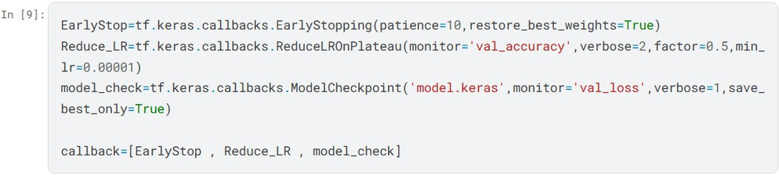

Early Stopping (EarlyStop):
Configuration: (patience=10, restore_best_weights=True).
Role: This acts as a safeguard. If the model stops improving for 10 consecutive epochs, the training terminates automatically. By restoring the best weights, we ensure that the final model is the one that performed best on validation data, not the one from the last (potentially overfitted) epoch.

Learning Rate Scheduler (ReduceLROnPlateau):
Configuration: (monitor='val_accuracy', factor=0.5, min_lr=0.00001).
Role: Deep Learning models often get stuck in "local minima." This callback monitors the validation accuracy; if it plateaus, it cuts the learning rate by half. This allows the model to take "smaller steps" to find the global optimum more precisely.
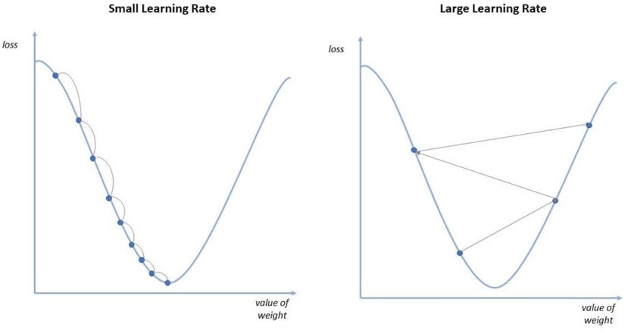

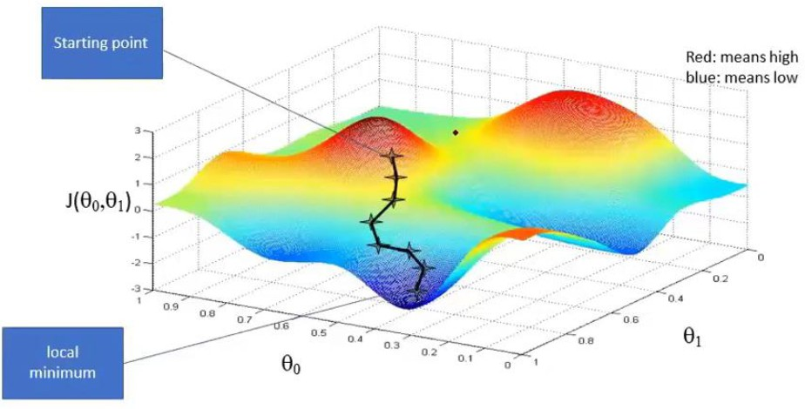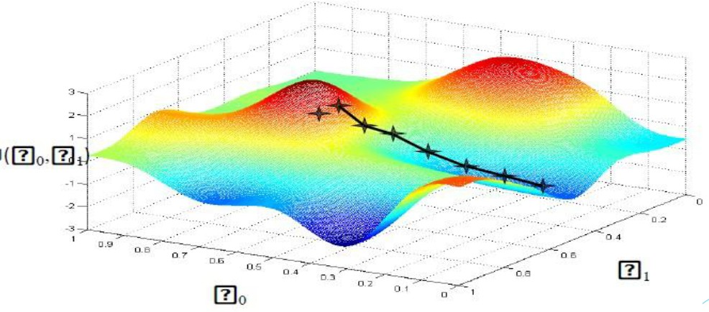

Model Checkpointing (model_check):
Configuration: (save_best_only=True, monitor='val_loss').
Role: It continuously monitors the val_loss and saves only the "best version" of the model to a file (model.keras). This ensures that even if a power outage or crash occurs, we have the most accurate version of the model saved.
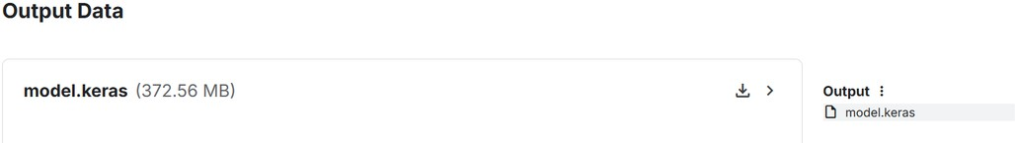

Experimental Results & Performance Metrics:
  - Quantitative Analysis
Metric

Dice Coefficient Pixel Accuracy
Mean IoU
Achievement

0.86

99.7%

0.75

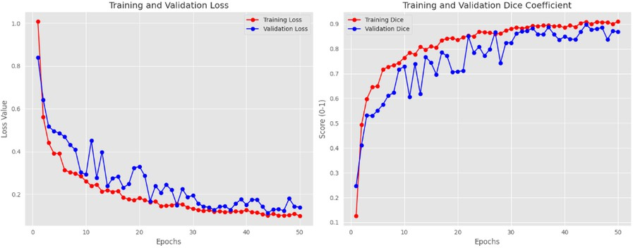
  - Qualitative Evaluation

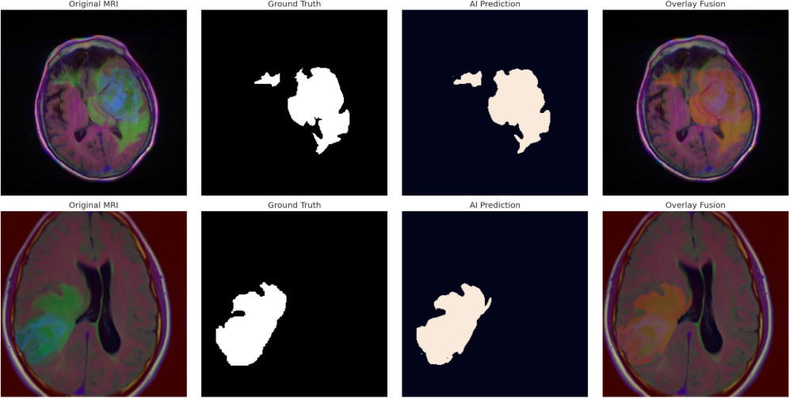

Deployment Strategy:
The final stage of this project involves moving from a Notebook to a Real-Time Deployment.
Platform: Streamlit-based Web Interface.
Optimization: Model quantization for faster inference on standard hospital hardware.
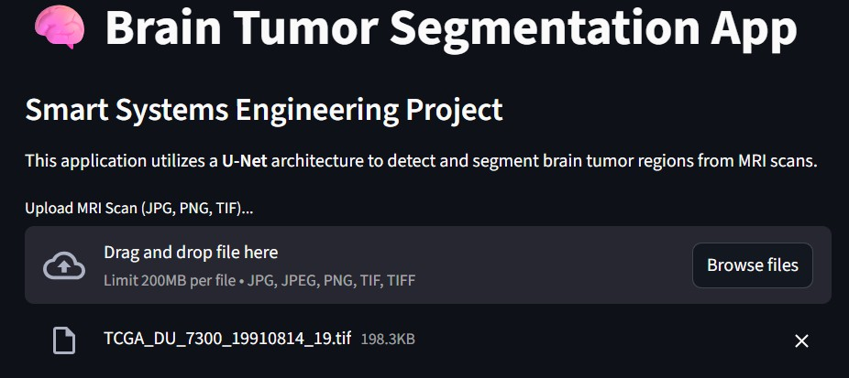

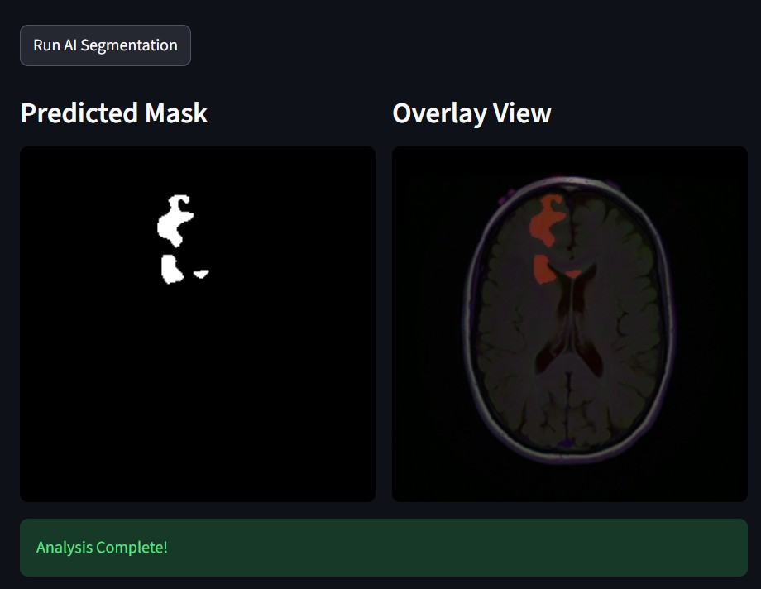

Conclusion:
In this project, an end-to-end medical imaging pipeline was developed to automate the segmentation of brain tumors from MRI scans using the U-Net architecture. The model demonstrated robust performance, achieving a Dice Coefficient of 0.86, which indicates a high degree of overlap between the predicted masks and the ground truth.

Key Technical Insights:
Architectural Efficiency: The use of skip connections in the U-Net proved essential for recovering spatial information lost during the down-sampling path, leading to precise boundary localization of the tumor.
Data Challenges: Addressing the class imbalance (tumor vs. non-tumor pixels) was a critical step, where the combination of Binary Cross-entropy and Dice Loss provided a more stable convergence.
Deployment Value: The integration of the model into a Streamlit web application bridges the gap between deep learning research and practical clinical tools, allowing users to perform real-time inference on various file formats, including .tif and .png.
Future Work: Future enhancements could involve integrating Attention mechanisms within the U-Net blocks to focus on smaller lesions and expanding the dataset to include multi-modal MRI sequences (T1, T2, and FLAIR) for a more comprehensive diagnostic tool.


Notebook Link on Kaggle :

